**DAILY ONLINE ACTIVITIES SUMMARY**

|  |  |  |  |  |  |  |  |  |
| --- | --- | --- | --- | --- | --- | --- | --- | --- |
| **Date:** | **06/07/2020** | | | | | **Name:** | **VIRESH** | |
| **Sem & Sec** | **4th SEM & ‘B’ SEC.** | | | | | **USN:** | **4AL18CS097** | |
| **Online Test Summary** | | | | | | | | |
| **Subject** | | **Complex Analysis, Probability and Statistical Methods** | | | | | | |
| **Max. Marks** | | **20** | | **Score** | | | **-** | |
| **Certification Course Summary** | | | | | | | | |
| **Course** | **Introduction to Cyber Security**  **Attended Salesforce-Job ready program &TCS internship program** | | | | | | | |
| **Certificate Provider** | | | **Greatlearning Academy** | | **Duration** | | | **7.0 Hrs.** |
| **Coding Challenges** | | | | | | | | |
| **Problem Statement 1:** Write a Java program to find the Nth natural number with exactly two bits set. | | | | | | | | |
| **Status: Executed.** | | | | | | | | |
| **Uploaded the report in Github** | | | | | **Yes** | | | |
| **If yes Repository name** | | | | | **Lockdown-Coding**  <https://github.com/viresh-kulal/Lockdown-Coding>  <https://github.com/alvas-education-foundation/Viresh/tree/master/coding_solutions> | | | |
| **Uploaded the report in slack** | | | | | **Yes** | | | |

**Online Test Summary:** **Today 18MAT41 Descriptive written test was conducted and there were three questions, the test was scheduled from 9:30am to 10:15am.Scores not received.**

**Online Certification Course Summary: Learnt about Information Security Management System, risks and policies, frameworks & ISO27001 Standard.**

**The snapshots of today’s session is attached below.**c

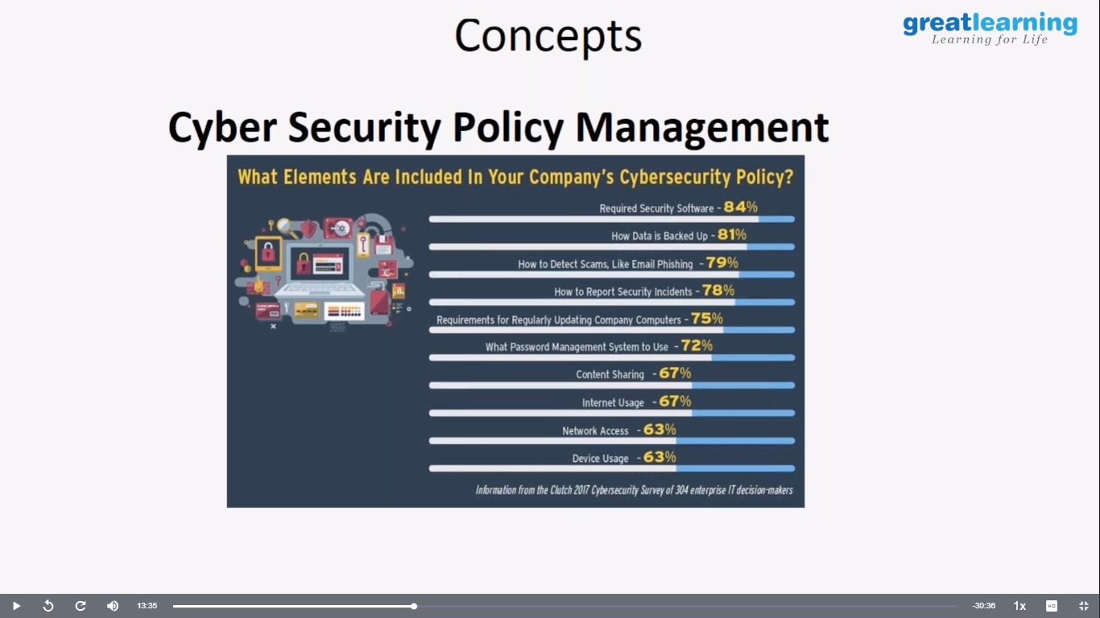 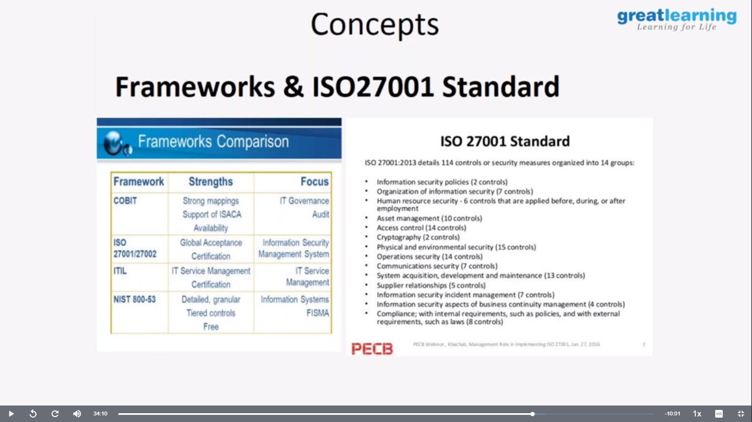

**Also I have attended the zoom meeting at 11:30Am conducted by AEF collaborating with Salesforce-Job ready program which is world’s #1CRM platform. Then I came to know about it’s a free online learning platform also which provides job opportunities to us. And also I have attended the zoom meeting at 02:30 pm about TCS RIO internship and I’ve understood about internship opportunities given by the TCS company.**

**Online Coding Summary: Today I had received one program from prof. Shilpa CSE Dept. The program is mentioned above in the coding challenges(pg.01). I have also uploaded it to my Github repository.**

The Repository link is: <https://github.com/viresh-kulal/Lockdown-Coding>

<https://github.com/alvas-education-foundation/Viresh/tree/master/coding_solutions>

**It is the snapshot of my repository where I have uploaded the code. File name is NaturalNumber.java** 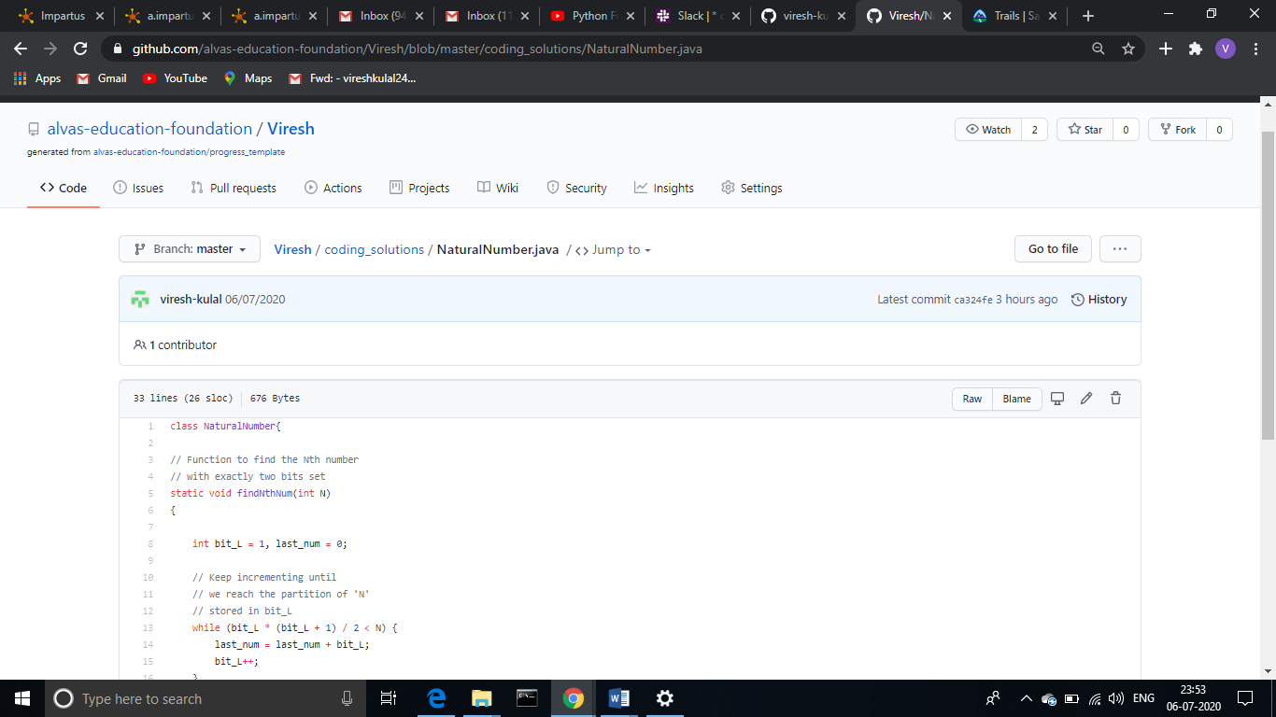

**Thank you.**